UIT IE229 – ARTIFICIAL INTELLIGENCE Homework (3) ニューラルネットワーク

解答用紙 (Answer Sheet)

学生証番号 (Student ID): 21522019

名前(Name): Âu Trường Giang (アーウ・チュオン・ザン)

問1.

(a)

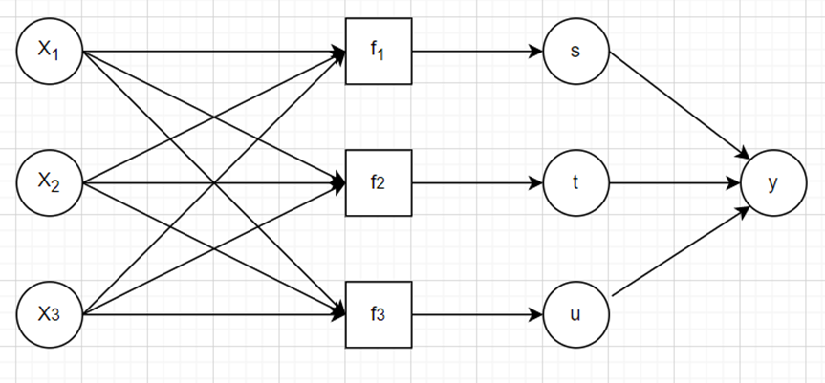

(b)

|  |  |  |  |  |  |  |  |  |  |  |
| --- | --- | --- | --- | --- | --- | --- | --- | --- | --- | --- |
| $$s$$ | 16 |  | $$t$$ | 168 |  | $$u$$ | 47 |  | $$y$$ | 30689 |

(c)

|  |  |  |  |  |  |  |  |
| --- | --- | --- | --- | --- | --- | --- | --- |
| $$\frac{∂y}{∂x_{1}}$$ | 2960 |  | $$\frac{∂y}{∂x_{2}}$$ | 2632 |  | $$\frac{∂y}{∂x_{3}}$$ | 75146 |